SellMyCraft User Manual



Table of Contents

1. Introduction 3

1.1 Overview 3

1.2 Getting started - Installation 3

1.3 Starting up 3

1.4 Navigation and interfacing 4

1.5 Help 6

2. Screen specific help 6

2.1 Login 6

2.2 Main Menu 6

2.2.1 Add Product 7

2.2.2 Edit Info 7

2.2.3 View Products 8

2.2.4 View Sales 8

2.2.5 Synchronization 9

2.2.6 Log-out 9

# Introduction

## Overview

The SellMyCraft e-Commerece application helps you reach and sell your products to a wider audience.

This application is designed using basic4android for android mobile devices. And is designed to be usable for touch-screen and point and click type interfacing.

## Getting started - Installation

To install the application, you must firstly either download the SellMyCraft.apk ([www.androiddownloads.com/sellmycraft.apk](http://www.androiddownloads.com/sellmycraft.apk)) file from the android store or website to your mobile device.

Then simply run the file and follow the prompts provided, once completed the program will be installed and usable on your mobile device.

## Starting up

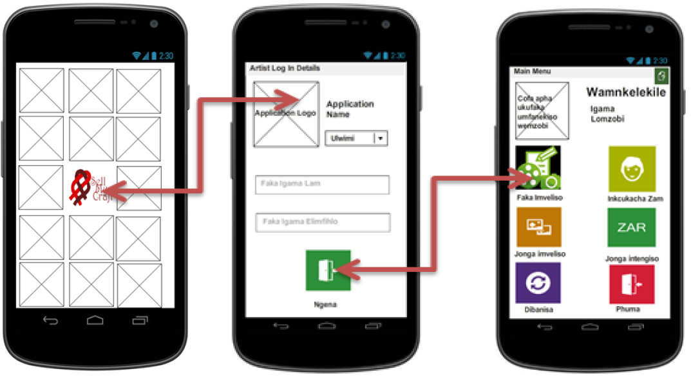Once the application is installed and loaded, you can find and start the application by clicking and/or opening the applications logo and executable file which will be located on your device where all other applications are found. From here you are brought to the login screen where-by once correctly logged in you’ll be brought to the program’s main screen.

## Navigation and interfacing

Upon starting the app you will be able to select the language with which the application would run on via a drop-down box which you click on and then select the appropriate language of your choice.

The program is navigated through a series of screens that is accessible once log in is successful. Clickable and usable buttons are represented and identifiable by icons and colour.

User input comes in the form of clicking or selecting editable text boxes and entering the appropriate information where applicable and when prompted. Example, log in information at application start-up.

External interfacing is conducted with regards to the application making use of the phone’s camera and default camera application.

The interface and navigation structure of the application is depicted below:

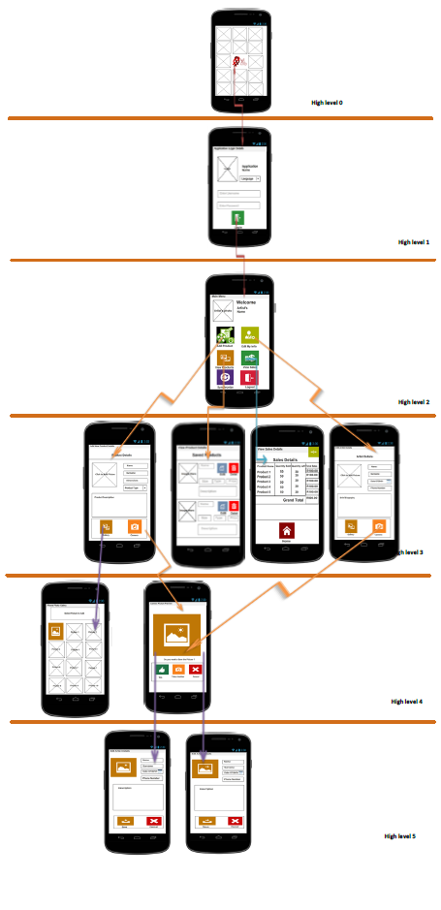

## Help

Help is provided within the app so you do not need to consult this manual, there is help provided for each screen and interface encountered within the application.

To access the application’s built in help, simply click on the Help icon present within a screen identifiable by its icon’s representation:

# Screen specific help

## Login

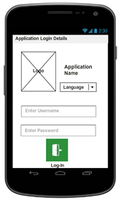

Upon application start-up the *Login* screen appears. Where-by the application’s *Language* setting is changeable via pressing on the presentable languages and selecting the language desired.

A username and password must be entered into the appropriately marked fields and upon successful entry press on the *Login* button will load the main menu.

## Main Menu

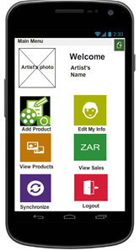

Upon login, the *Home* screen will be displayed with the photo and name of the user. The user can perform 6 actions on the *Home* screen through pressing on the appropriate icon’s namely:

* Add Product
* Edit My Info
* View Products
* Views Sales
* Synchronize
* Logout

### 2.2.1 Add Product

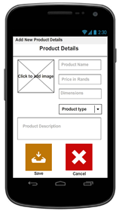Clicking the *Add Product* button on the Home screen opens this screen.

The new window will be displayed with fields where new product details can be entered such as product name and price through pressing on the field then using the phone’s QWERTY keyboard to make the appropriate changes. A picture of the product will have to be uploaded by selecting an existing picture from phone’s gallery or by way of taking a new picture using the phone’s camera, selectable through pressing on the appropriate response when prompted.

When satisfied with the details and the uploaded picture, press the *Save* button and these changes will be saved on the mobile application. Alternatively, press the *Cancel* button and the changes will not be saved and the *Home* screen will be displayed. The phone’s *Back* button can also be used to go back to the *Home* screen.

### 2.2.2 Edit Info

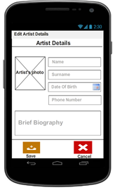Clicking the *Edit My Info* button on the Home screen opens this screen.

A new window will be displayed with fields with the artist details and picture displayed. These displayed details and picture can be edited as required through clicking on the field and then using the phone’s QWERTY keyboard to make changes. The artist picture can be changed by clicking on the current picture and either uploading an existing picture from phone’s gallery or by way of taking a new picture using the phone’s camera. When satisfied with the artist details and the uploaded picture, select the *Save* button and these changes will be saved on the mobile application. Alternatively, select the C*ancel* button and the changes will not be saved and the *Home* screen will be displayed. The *Back* button can also be used to go back to the *Home* screen.

### 2.2.3 View ProductsC:\Users\g97k5191\Desktop\ITS\Product View Report Screen.PNG

Clicking the *View Products* button on the Home screen opens this screen.

A new window will be displayed showing all products that are currently on sale including all the relevant details such as price. These details can be changed by pressing the *Edit* button where you’ll be brought to a new window where changes can be made through presses and the use of the QWERTY keyboard. When satisfied with the edited details, press the *Save* button and these changes will be saved on the mobile application. Alternatively, press the *Cancel* button and the changes will not be saved and *View Products* window will be redisplayed. The phone’s *Back* button can be used to go back to the *Home* screen.

### 2.2.4 View Sales

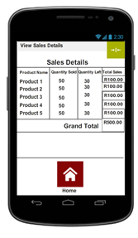

Pressing the *View Sales* button on the Home screen opens this screen.

A new window will be displayed showing the details of all sales that have been made in tabular format. Details about the product sold, quantity sold, quantity left and total cost will be shown. The Sales details are not editable. Press the *Home* button to go back to the *Main* screen.

### 

### 2.2.5 Synchronization

Select the *Synchronise* button on the Home screen. This allows all changes or updates to be saved on the Teleweaver database. It is important to ensure that this is done at all times when any changes are made.

### 2.2.6 Log-out

Select the *Logout* button on the Home screen. This will close the mobile application and login details will have to be provided to access the application.

# In-phone help screens

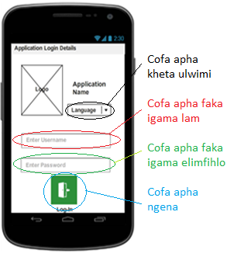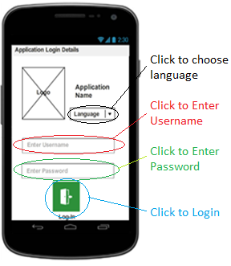Login:

Main menu:

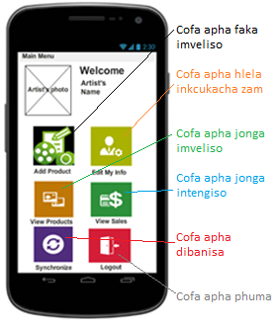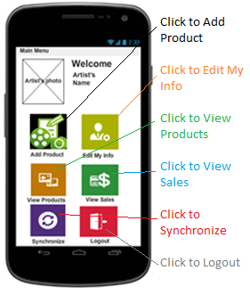

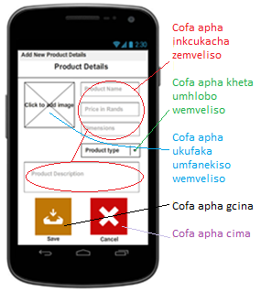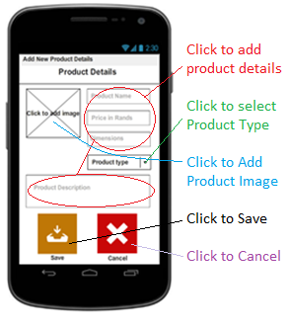Add Product:

View Products:

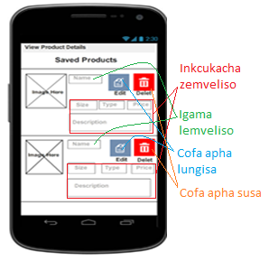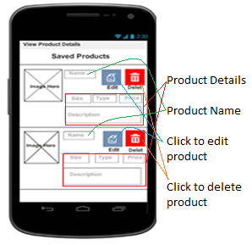

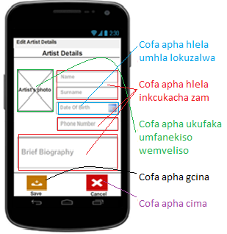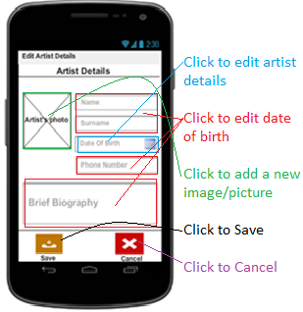Edit Artist information: